Data Analytics Gym – Documentation
9/27/2026
Keep in mind for the Excel-Project: separate tables to keep the workbook clean. For example, raw data | analysis | dashboard.
Same, Same, Same, but Different:
AVERAGEIF()/AVERAGEIFS() | COUNTIF()/COUNTIFS | SUMIF/SUMIFS
Average/Count/Sum range first → criteria range → criteria → criteria range → criteria
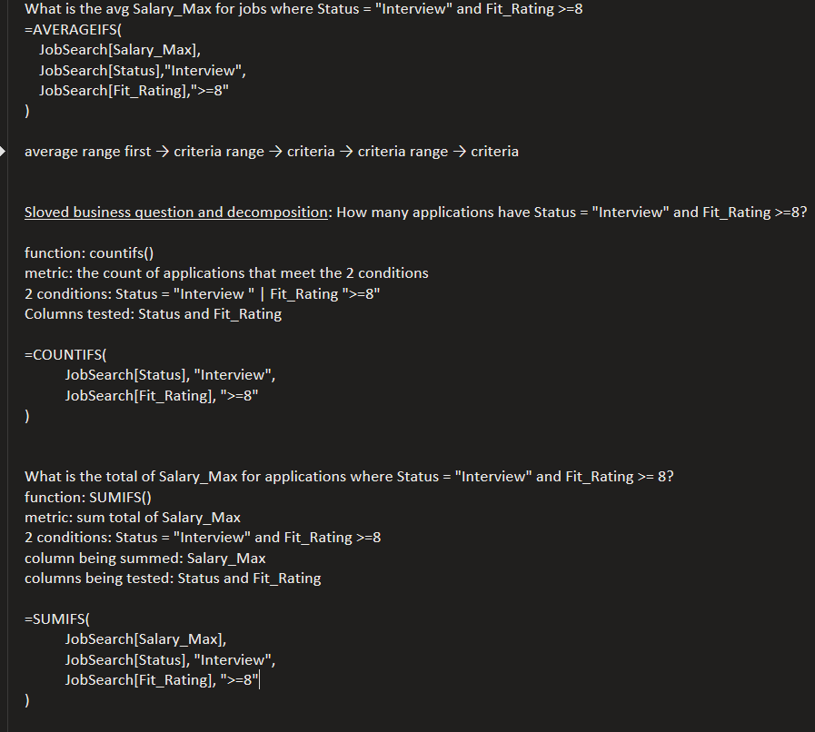

9/26/2026
Need to drill in the basic concepts of Python/Pandas. Feels unfamiliar when using multiple concepts at once.

9/22/2026
= assigns. == compares
jobs[
(jobs["salary"] >= 80000)
& (jobs["status"] == "Interview")
]
- Shows only jobs with salary at least 80,000 and status equal to "Interview".
- The & is the operator that combines both Boolean conditions
  - This is like AND within Where Clause for SQL

9/21/2026
Brushing up on Python/ Pandas concepts:
- Using Boolean Mask as a way to filter a selection within a field(s)
  - Df[“field”].isin([“record_a”,”record_b”])
- The method to find average is .mean() not avg()
  - Usually the method gets connected after the calculation
    - jobs.groupby("status")["salary"].mean()
      - in the jobs df, group records by the different status records and show the average salary associated with each application status
- To join data frames in Pandas, use .merge()
  - jobs.merge(
  - companies,
  - on="company_id",
  - how="left"
  - )
- left_dataframe.merge(right_dataframe, on="key", how="join_type")
9/17/2026
Continued making flashcards with Python: using as a validator to SQL results.
Completed another round of simulated operational workflow/processes and how in regard to incomplete or missing items in a client’s delivery.
Input | Process | Handoff | Output | Measurement

9/16/2026
Today, we are pivoting and taking a different approach to my development in light of a new position I’d be starting in a couple weeks.
Operational Thinking Before Optimization
- Before making changes to workflows or optimizing a process, FIRST understand why did this exist in the first place.
  - Therefore, when evaluating operations ask: How does this actually work?

Use this framework as a general way to evaluate operational workflows/processes:
Input: What starts the work?
Process: What happens to the request?
Handoff: Who or what receives it next?
Output: What does "finished" actually mean?
Measurement: How would we know whether the process is working well?

The following is a Synthetic Scenario Exercise:
Mapping the Current State
Occasional complaints from partners that some requests take a long time.
Input: partner-emailed request within inbox
Process: a dedicated or any available employee notices the email (seems random not standardized/ regularly scanned) and manually enters request into a shared Excel tracker. After that, an organization’s info is reviewed in the database (2nd home for the same information). If there is mission information, an employee has to reach back out to partner for clarification; this back and forth potentially causes delays in updating partner information. After a response, there seems to not be a dedicated resolution because sometimes the available employee will update the Excel or not (wtf, that’s there job).
Handoff: If changes require supervisor approval, staff must send a Teams message to super for review (an employee may or may not do this/ forgetful/ delayed request to super). Here’s what I don’t like: once a super reviews the request, they then have to message the employee back for them to reach back out to the parter notifying completion of their update request.
Output: At the end of the month, the super must manually count completed rows in Excel to report completed request summary for the month.
Current Measurement: The only way to measure if the process was working well was if complaints about request-completion times were reduced.
There’s no tracker for how long requests are taking to process. That metric could be valuable in identifying bottle necks.
There must be a way to reduce time for repetitive manual data entries, keeping data in a centralized location versus having multiple versions of the same data (loss of data integrity), and a way to reduce dead space between handoffs for verifications.

Diagnose Before Fixing
Is there a priority pipeline for the tasks we handle on a regular basis? How would we define priority order? This would provide direct guidance on which tasks to prioritize. Every partner service representative would be trained on how to support partners. Therefore, anyone would be able to jump in and complete tasks. I would request that documentation be built in to daily tasks for transparency and clarity of work being done.
Is there a system to track completion of types of work we do on a regular basis? Identifying the average completion time could help locate inefficiencies and be the start to reducing prolonged wait times.
Is there a way to have one location where partners info can be inputted and stored? Reducing multiple locations of the duplicate data could reduce confusion, support data security and accurate records.
Can we design some sort of ticketing system to organize regular work? This way tasks can live in a central place instead of being spread across email threads and teams messages. Maybe Teams can be utilized more like Slack; making quicker reference to projects and ideas: can Teams be utilized the same way?
If things require supervisor approval, can they be batched and ranked and ordered by priority so that the super can have a systemized way to process work efficiently?

Importance of understanding and investigating a process before trying to improve it:
we would want to provide relevant solutions instead of create unnecessary work for everyone. change can already be challenging, and if i propose solutions that create more problems that solve, that's very ineffective and bad for the team and clients.
- Understand and investigate the current process so that changes address the actual cause of a problem rather than an assumption. A good improvement should make the operation more effective without unnecessarily increasing workload, complexity, or friction for employees and partners.
9/15/2026
Getting in reps for designing data for Life CC:
- What business/user question are we actually trying to answer?
  - How to combine the two things my father prioritizes in his life: financial and physical health, and showcase an overview of progress and goals? Furthermore, how can we design it so that, when my dad interacts with the app, it would create a sense meaningful work and purpose?
- What metric or metrics would matter?
  - Total income, expenses and debt
  - Count days of exercise
  - Average sleep per week
  - Calories per day | count of macronutrients consumed daily | days adherence to MyPlate method of eating
  - Count of bills paid for the month

- What raw fields would we need to collect?
  - Monthly bank statements
  - Debt balances
  - Lab reports from doctor’s appointments
  - Bp
  - Food log
  - Apple watch activity: steps, calories burned, rings close rate
  - Work outs
  - Sleep log
    - Correction:
      - transaction_date, amount, category, systolic_bp, diastolic_bp, lab_test_name, lab_value
- What would the grain of the exercise data be?
  - One row per day or one row per workout session
- What entity or entities do you think exist?
  - I want to say there’s just one entity: my dad. But I’m not sure. Maybe: health, finances, so then two entities?
- Would you store everything in one table, or do you already see a reason for multiple tables?
  - I see multiple tables: income/expenses, debt, lab results, food log, exercise log, and sleep log

9/14/2026
Continuing with SQL Drilling: Group By vs Window Function.
Knowing when to use CTE vs Window Function:
- Need to change grain first? Think CTE/subquery.
- Need to keep the current grain and add context? Think window function.
Getting used to decomposing the business questions before starting with SQL; normally I would just start trying to write SQL to solve the business problem.
Now it’s like understanding a math problem fully and then hand-picking the concept or formula to solve the problem first.
- In SQL, that means decomposing the business question into grain, metrics, relationships, and required transformations before choosing the appropriate query logic.

9/13/2026
Started with some join logic and difference between distinct and Group By in a CTE to achieve the same result; CTE above/below average comparisons.
In telling stories to showcase my experiences, use this format:
- Problem: what were you trying to improve?
- Data: what did you track?
- Analysis: what did you actually do with the data?
- Decision: what changed because of the analysis?
- Impact: what measurable result came out of it?
I also created flashcards to help me with basics of SQL and some window functions.

Quick story for when asked about one of my analytics projects and what impact it had:
When I started doing DoorDash, I wanted to find a way to earn more money in less time while also reducing unnecessary mileage and gas costs. So essentially, work smarter, not harder.
I started tracking daily earnings, shift times, miles driven, earnings per mile, and hours worked per shift. Then I analyzed those metrics to look for trends when I was most efficient and which shifts were actually worth my time.
Based on what I found, I changed how and when I worked. As a result, I increased my earnings from about $9 per hour to around $18 per hour, improved my earnings per mile from roughly $0.50 to at least $2.00, and reduced the time it took to hit the same daily earnings goal from about 6–7 hours to 3–4 hours.
What I liked about that project was that it showed me how useful even simple data can be when it’s tied to a clear business question and a decision.
Tell me about yourself:
From running my own fitness business, I’ve always been interested in using metrics to improve results for my clients and make better business decisions.
When I transitioned to Three Square as a Nutrition Education Specialist, I was regularly reviewing performance metrics, improving processes, and using data to help support health and operational goals for the Las Vegas community.
That experience pushed me to go deeper into analytics. I started building my skills in SQL, Excel, Power BI, and more recently Python, and I found that I really enjoy using data to solve practical problems and improve how systems work.
What interests me about Mercury is the opportunity to keep developing those technical skills while contributing to a team that works across analytics, data, and systems. I think my background in operations, problem-solving, and analytics gives me a strong foundation to contribute while continuing to grow.

9/12/2026
- a CTE can create a new state-level dataset
- aliases inside the CTE do not carry outside it
- aggregate functions work on columns/expressions, not the CTE name itself
- the outer query can compare each row against an aggregate of the CTE

9/11/2026
Went over concepts of joins. Instead of syntaxes in isolation, my goal is to understand purpose and function of SQL concepts, but also develop the ability to apply them to various scenarios; effective application within real world.
My process: Understand the Business question → identify the underlying problem → choose the right concept/tool → write the syntax, produce the results/insights that lead to solutions to the problem.
9/10/2026
Conducted Testing on everything I’ve learned so far, then updated oneNote. Focusing on knowing when to apply certain Window Functions based off of business needs. Growing past learning Window Functions in isolation.
9/9/2026
Learning First_Value() and Last_Value() with Window Frames
- Business-wise, FIRST_VALUE() is useful for comparing current performance to a starting baseline, while LAST_VALUE() is useful for comparing rows to the final value in a defined sequence.
- Window Frame = defines how much of a sequence a function can see

9-8-2026
Practiced Lag() – Value/Navigation windows
Drilled in concept for calculating Percent Change: percent change = (new - old) / old × 100

9-/7-2026
Starting very first DA Gym exercise:
- Partition By()
  - define the boundaries of the window, so the function is applied separately within each group/window
- Order By()
  - Difference between within Window Function vs Outside; Running Total vs Final Result Ordered normally w/o Running Total
- Row_Number()
- Rank()
- Dense_Rank()
- Lag()
  - Pull the (X) value from the previous row
    - Define the field I want the value from and pull a previous record git

9-6-2026
- Created Repos and README.md file.

